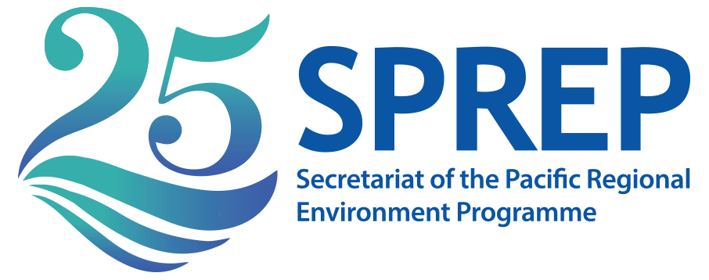

APPLICATION FORM: CLIMATE REPORTING MASTERCLASS
Please fill in and send back to sprep@sprep.org by 4.30pm Samoa time on 8 April, 2019 with the words Climate Reporting Master Class in the subject.
Name:
Age: |  |  |  |  |  | Gender:
Name of Media Organisation:
Country of application:
Your position:
Address:
Email address (both personal and professional):
Phone number (both work and personal)
Number of years you have been working in Pacific media:
Why do you believe you should be chosen for this opportunity?
Do you report often on climate change? Please explain
Please list the media genre you work in/will be working for when covering the PRM.
Please list the technical equipment you will be bringing with you
Please check you have attached the following items to this application:
CV |  |  | Two examples of past work |  | Letter of support from your News Editor/Head of Media organisation

