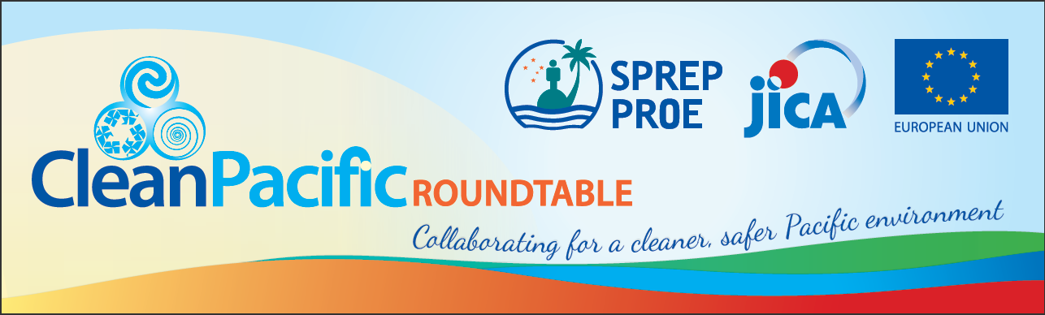

ANNEX 1

Clean Pacific Roundtable 2018 and associated events
Location – PIFS Conference Room, Suva, Fiji
20th – 25th August 2018

provisional agenda
Date and Time | Schedule
Day 1: 20 August 2018
Session 1.1: Opening Programme
9:00am – 9:45am | Opening Programme of the CPRT
9:45am – 10:00am | Photo Session
10:0am – 10:30am | Coffee Break
Session 1.2: Stakeholder Involvement in Waste Management (Plenary Roundtable)
10:30am – 11:15 | Keynote Address
11:15am – 12:30pm | Enhancing Social Responsibility in Waste Management (TBC by 2018 Organising Committee)  Chair and Moderator: TBC by 2018 Organising Committee
12:30pm - 1:30pm | Lunch Break and Side Event #1 (TBC)
Session 1.3: Emerging Waste Streams (Parallel Roundtables)
1:30pm – 4:00pm  (concurrent sessions) | Parallel Session 1.3.A: Coordinated actions to combat marine debris  Chair and Moderator: TBC by 2018 Organising Committee | Parallel Session 1.3.B: Planning and Responding to Disaster Wastes  Chair and Moderator: TBC by 2018 Organising Committee | Session 1.3.C: Enhancing proper management of hazardous wastes  Chair and Moderator: TBC by 2018 Organising Committee
4:00pm – 5:00pm | Organisation of the 2020 Clean Pacific Roundtable (CPRT) and Technical Working Groups (TWGs)
5:00pm – 5:15pm | Synthesis of Day 1: Country Representative (TBC)
5:15pm onwards | Breakout meetings of TWGs
7:00pm | Welcome Dinner (to be hosted by ________)
Day 2: 21 August 2018
Session 2.1: Sustainable Waste Management (Plenary Roundtable)
8:30am – 9:15am | Keynote Address
9:15am – 10:15am | Ensuring Sustainable Mechanisms in Waste Management (TBC by 2018 Organising Committee)
10:15am – 10:45am | Coffee Break
Session 2.2: Coordinated Actions in Waste Management
10:45am – 12:30pm | Session 2.2.1: Regional Coordination in Recycling  Chair and Moderator: TBC by 2018 Organising Committee
12:30pm – 1:30pm | Lunch Break and Side Event #2: Outcomes of the Resource Circulation Investigation (PRIF) - TBC
Session 2.3: Enabling Systems in Waste Management (Parallel Roundtables)
1:30pm – 4:00pm  (concurrent sessions) | Session 2.3.A: Boosting eco-tourism through proper waste management  Chair and Moderator: TBC by 2018 Organising Committee | Session 2.3.B: Further Enhancement of Regional Capacity in Waste Management  Chair and Moderator: TBC by 2018 Organising Committee | Session 2.3.C: Ensuring More Informed Decisions in Waste Management  Chair and Moderator: TBC by 2018 Organising Committee
4:00pm – 4:15pm | Synthesis of Day 2: Donor Representative (TBC)
4:15pm onwards | Meeting of the 2020 CPRT Steering Committee
6:00pm – 8:00pm | Cocktails and Side Event #3: Launching of the Pacific SWM Guidebook
Day 3: 22 August 2018
Session 3.1: Resolution and Outcomes (Plenary Roundtable)
8:30am – 11:30am | Chair’s Summary of Roundtable Discussions and Way Forward (Resolutions and Outcome Statement)  Chair and Moderator: CPRT Steering Committee
11:30am – 12 noon | Closing Programme of the CPRT
12noon – 1:00pm | Lunch Break and Side Event #4 (TBC)
Session 3.2: Launching of the Regional Waste Monitoring System
1:00pm – 5:00pm | Launching of the Regional Waste Monitoring System  Facilitators: Ma. Bella Guinto/Mahmoud Riad/Yasuko Onoue
Day 4: 23 August 2018
Session 4: PacWaste Plus Inception Workshop
8:30am – 5:00pm | PacWaste Plus Inception Workshop  Facilitators: EU Delegation and WMPC Team
Day 5: 24 August 2018
Session 5: J-PRISM2 2nd Steering Committee Meeting
8:30am – 5:00pm | J-PRISM2 2nd Steering Committee Meeting  Facilitators: Shiro Amano and J-PRISM Project Team
Day 6: 25 August 2018
Session 6: Marine Litter and Microplastics Data Collection Training
8:00am – 12noon | Marine Litter and Microplastics Data Collection Training  Facilitator: Anthony Talouli & Heidi Taylor (Tangaroa Blue Foundation)

