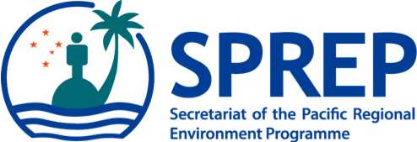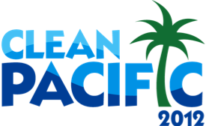
PO Box 240, Apia, Samoa
E: sprep@sprep.org
T: +685 21929
F: +685 20231
W: www.sprep.org
The Pacific environment, sustaining our livelihoods and natural heritage in harmony with our cultures.
Pacific Regional Preparatory Meeting
for the
11th Conference of the Parties to the Convention on Biological Diversity

10 – 13 August 2012, Rotorua New Zealand

Draft Provisional Agenda

- Opening

- Introduction of Participants and Resource People

- Meeting Objectives

- Adoption of Agenda and organization of work

- Overview of the CBD

- Country Presentations

- COP11 Priority Issues for the Pacific

- Key Messages for COP11

- Pacific Voyage Communication and Media Plans

- Negotiation Refresher Training

- Pacific Voyage Roadmap to COP11

- Closing

