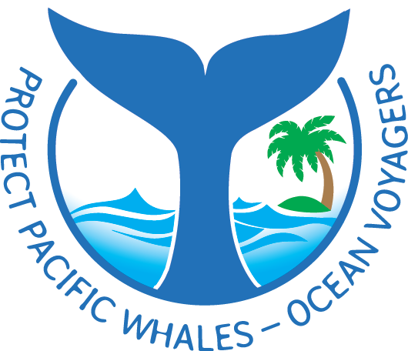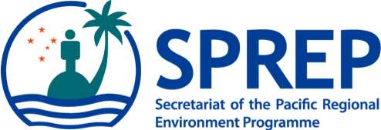
PO Box 240, Apia, Samoa
E: sprep@sprep.org
T: +685 21929
F: +685 20231
W: www.sprep.org
The Pacific environment, sustaining our livelihoods and natural heritage in harmony with our cultures.

GEF-UNEP Building National and Regional Capacity to implement Multilateral Environmental Agreements (MEAs) by strengthening planning and State of Environment Assessment and Reporting in the Pacific Project Inception Workshop
20 – 24 November, 2017 at the SPREP Headquarter at Vailima, Samoa.

Nomination Form

First Name: Last Name:

Job Title:

Department: ______________________________________

Country: ______________________________________

Address:

Telephone:

E-mail:

Please email the completed Registration by 6th October 2017 to: Pauline Fruean: paulinef@sprep.org

