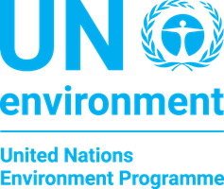
Annex 2: Nomination Form
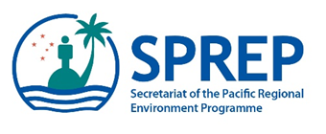

CBD Pre-COP Meeting and
CBD-6NR Technical Support Workshop for Pacific Region,
24th – 28th September 2018, SPREP campus, Apia, Samoa

Please nominate one country participant who will be a representative on the National delegation to the CBD CoP 14, or concurrent meetings of the COP-MOPs in Egypt; and who is preparing the CBD 6th National Report.

If this is not the same person then please complete and submit an additional nomination form for an additional participant.
Name:

I will be on my countries National delegation for CBD CoP 14 | YES | NO
I am responsible for preparing the CBD 6th National Report | YES | NO
My country has funding through the UN Environment/UNDP 6NR project | YES | NO
I will make my own travel arrangements and fund from the 6NR project budget | YES | NO, I require financial assistance for travel
Name as in Passport: (Tick if same as above)

Country:

Job Title/Designation:

Organisation& Department:

Postal Address:

Phone No.:

Email Address:

Please email the completed nomination form no later than Friday 31 August 2018 to Amanda Wheatley amandaw@sprep.org and Antony Kamau antony.kamau@un.org. Please also send us a copy of your passport biodata page for your travel arrangements.

