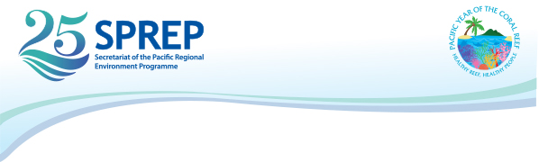
Pacific Preparatory Meeting for UNFCCC COP24
31 October – 3 November 2018
Nadi, Fiji

NOMINATION FORM FOR PARTICIPANTS
(Please type or print)

IMPORTANT NOTICE: Please forward a copy of your passport and complete this form in full and submit through email to: Filomena Nelson (filomenan@sprep.org), Climate Change Adaptation Adviser and Teuila-Jane Fruean (teuilajanef@sprep.org) no later than 28th of September 2018.

Sex Male Female

Family Name First Name Other names

- Passport Number: (Please attach a copy of the first page of your passport)

- Date of birth:

- Present official title/position:

- Ministry:

- Government of:

- Head of Delegation : Yes No

- Mailing address (office) :
9. Tel. No. (office) Fax. No.

- E-mail (essential):

- Airport of departure:
We encourage participant to give us the most accurate/right information in order for us to process your travel without any issues.
PO Box 240, Apia, Samoa T +685 21929 F +685 20231 sprep@sprep.org www.sprep.org
A resilient Pacific environment sustaining our livelihoods and natural heritage in harmony with our cultures.

