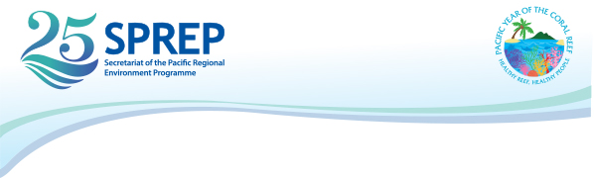

Regional Inform Project Meeting
19th – 22nd August 2019, Apia, Samoa

Nomination Form

Full Name : ____________________________________________________
(as shown in passport)

Job Title : _____________________________________________________

Organisation: __________________________________________________

Office Address: ________________________________________________

Country:_____________________________________________________________

Phone Number: _________________________________________________

Mobile Number: ________________________________________________

Email: _________________________________________________________

Please email the completed Registration as well as a copy of your passport biodata page by 17th May 2019 to: Pauline Fruean: paulinef@sprep.org and cc: lagir@sprep.org

PO Box 240, Apia, Samoa T +685 21929 F +685 20231 sprep@sprep.org www.sprep.org
A resilient Pacific environment sustaining our livelihoods and natural heritage in harmony with our cultures.

