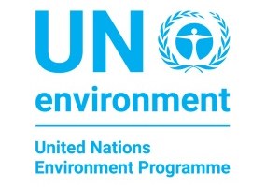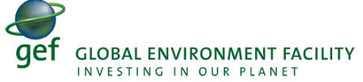
SUB-REGIONAL WORKSHOP ON ACCESS AND BENEFIT SHARING
CAPACITY BUILDING ON THE USE OF ABS CLEARING HOUSE, MONITORING & REPORTING ON THE UTILISATION OF GENETIC RESOURCES UNDER THE NAGOYA PROTOCOL.
Tanoa International Hotel, 7-10 October 2019
NOMINATION FORM
NAME
PREFERRED TITLE | Dr☐ | Mr☐ |  | Mrs☐ |  | Ms☐ | others☐
ORGANISATION OR AGENCY
CONTACT NUMBER | Office |  | Click or tap here to enter text. |  | Mobile |  | Click or tap here to enter text.
EMAIL ADDRESS | Click or tap here to enter text.
JOB DESIGNATION | Click or tap here to enter text.
COUNTRY | Choose an item.
CITY OF DEPARTURE | Click or tap here to enter text.
PASSPORT NUMBER | Click or tap here to enter text.
ANY HEALTH, DIETARY OR SPECIAL NEEDS | Click or tap here to enter text.
PLEASE ATTACH A COPY OF THE PASSPORT | ATTACHED ☐

ENDORSEMENT
I wish to confirm in my capacity as the National Focal Point for Nagoya Protocol / CBD National Focal Point that the above officer has been nominated to attend the CAPACITY BUILDING ON THE USE OF ABS CLEARING HOUSE, MONITORING & REPORTING ON THE UTILISATION OF GENETIC RESOURCES UNDER THE NAGOYA PROTOCOL.

………………………………………………………………..
Name and signature

Please complete this form and email it to absproject@sprep.org before 30 August 2019. Please attach a copy of your passport with the nomination form.

