Secretariat of the Pacific Regional Environment Programme (SPREP)

APPLICANT INFORMATION PACKAGE
DIRECTOR GENERAL (DG)

CONTENTS

- Background Information on SPREP

- Job Description

- Remuneration Package – Terms & Conditions

- Administrative Information

A. Background Information on SPREP
SPREP is the regional organisation established by the Governments and Administrations of the Pacific charged with protecting and managing the environment and natural resources of the Pacific. It is based in Apia, Samoa, with about 95 staff and an annual budget of USD $20 million in 2015.
The establishment of SPREP sends a clear signal to the global community of the deep commitment of Pacific island Governments and Administrations to better management of the environment as a key element of sustainable development.
The future directions for SPREP are clearly set out in the 2011-2015 SPREP Strategic Plan. This Plan outlines the mandate, vision and programmes for the organisation. The Strategic Plan places strong emphasis on effective delivery of services to SPREP Member countries and territories.

Mandate
SPREP’s mandate is to promote cooperation in the Pacific region and provide assistance in order to protect and improve its environment and to ensure sustainable development for present and future generations.

Vision
SPREP is guided by its vision for the future: “The Pacific environment, sustaining our livelihoods and natural heritage in harmony with our cultures”.
Members
SPREP has 21 Pacific island member countries and territories (American Samoa, Cook Islands, Federated States of Micronesia, Fiji, French Polynesia, Guam, Kiribati, Marshall Islands, Nauru, New Caledonia, Niue, Northern Marianas, Palau, Papua New Guinea, Samoa, Solomon Islands, Tokelau, Tonga, Tuvalu, Vanuatu and Wallis & Futuna) and 5 developed countries (Australia, France, New Zealand, United Kingdom and United States of America) with direct interests in the region.

Divisions
The SPREP Strategic priorities are delivered through four divisions:
- Climate Change: has lead responsibility for Adaptation, Science & Policy and Mitigation.
- Biodiversity & Ecosystem Management: has lead responsibility for Coastal & Marine, Threatened & Migratory Species, Invasive Species and Biodiversity.
- Waste Management & Pollution Control: has lead responsibility for Hazardous Waste Management, Pollution and Solid Waste Management.
- Environmental Monitoring & Governance: has lead responsibility for Environmental Monitoring & Planning and Governance.
The divisions work in an integrated way on project development and implementation.

Corporate Services & Internal Audit
Corporate Services provide corporate support to the delivery of the Secretariat’s strategic priorities and include Finance & Administration, Human Resources Management, Information Technology, Information Resources & Archives, Communications & Outreach and Monitoring & Evaluation. The Internal Audit Unit provides independent monitoring of the organisation's operations and governance procedures including risk management and internal controls.

B. JOB DESCRIPTION

Job Title: | SPREP Director General (DG)
Division: | Executive
Group / Team: | Senior Management Team
Responsible To: | Members, principally through the SPREP Meeting and its Chair
Responsible For:  (Total number of staff) | All Staff
Job Purpose: | This job exists to:  - Provide strategic leadership, direction and management to the Secretariat  - Be fully informed on stakeholder needs and realities, especially those of Members  - Keep Members fully informed on all aspects of the Organisation's operations
Date: | January 2015

Organisation Context

A. ORGANISATION

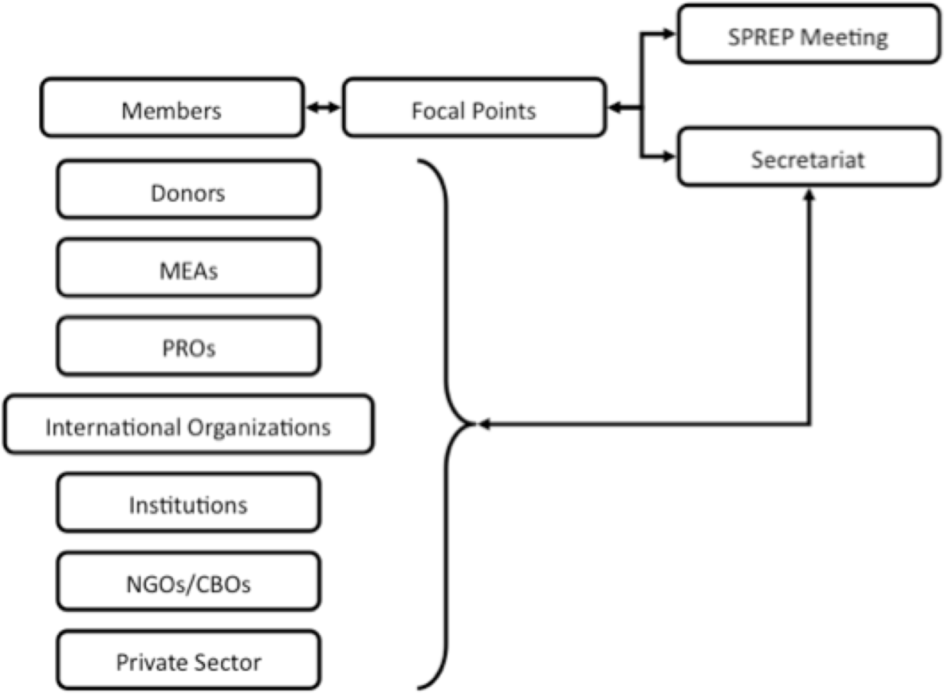

B. SECRETARIAT

Key Result Areas

The position of Director General (DG) addresses the following Key Result Areas:

- High Quality Strategic Leadership and direction
- High Quality Strategic Organisational Management and Planning
- Effective and Efficient Preparation and Implementation of the Strategic Plan
- Successful SPREP Meetings and Effective Environmental Advocacy
- Effective and Productive Donor Liaison, Regional Coordination and Cooperation, and Networking

The requirements in the above Key Result Areas are broadly identified below:
Jobholder is accountable for | Jobholder is successful when
- High Quality Strategic Leadership and direction  - Provide strategic leadership and direction for the Secretariat  - Lead the Executive Management Team in providing an integrated approach to strategic and organisational planning, programme design, work programme and budget implementation, performance monitoring and evaluation, and building partnerships to ensure the ongoing success of SPREP  - Lead the Senior Management Team meetings and discussions on all key decision making for the strategic direction and management of the Secretariat  - Provide guidance to the SPREP Meeting on key strategic issues for the effective and efficient management of the Secretariat  - Lead the evaluation of strategic leadership of the Secretariat | - Innovative, charismatic, effective and efficient leadership and management of the Secretariat  - The SPREP meeting is kept fully informed of the leadership and management of the Secretariat  - Demonstrates accountability to Members, and a high level of Member satisfaction  - The SPREP Chair is kept regularly and fully briefed on relevant management and other issues at SPREP  - The Secretariat has a strong and effective Senior Management Team  - The Secretariat has a strong, active and effective team of programme and administrative staff  - Transparent executive management performance review accepted by Members and by stakeholders
- High Quality Strategic Organisational Management & Planning  - Provide leadership and management of SPREP’s Work Programmes, Staff and Assets  - Keep up to date with knowledge of strategic management and organisational issues and identify implications and opportunities for SPREP | - Annual Work Plan and Budget successfully achieved and accepted by SPREP Meeting  - SPREP shows leadership and constructive cooperation and collaboration at a regional level, especially with other CROP agencies  - Sound appreciation of the Pacific regional context is demonstrated
- Effective and Efficient Preparation and Implementation of the Strategic Plan  - Lead the process to prepare the Strategic Plan  - Ensure that the Strategic Plan is successfully implemented by SPREP Secretariat and strongly urge members to do so  - Increase the delivery of relevant programmes and activities that benefit Member countries | - Strategic Plan prepared and meets the identified priorities of the SPREP mandate and of Members  - Strategic Plan successfully implemented  - Strategic priorities successfully achieved  - Member countries are satisfied with level of services provided by SPREP
- Successful SPREP Meetings & Effective Environmental Advocacy  - Support Members leading up to, during and following the SPREP Meeting and ensure this and other key strategic meetings for SPREP are effectively implemented and achieve successful results  - Advocate strongly for environment concerns of the regions  - Represent SPREP at high level regional and international meetings | - Successful annual SPREP meetings  - Key SPREP meetings enhance membership engagement, increase profile for the environment and increase the technical focus, effectiveness and relevance of SPREP’s work  - SPREP recognised and respected as premier environmental organisation for the region  - Engagement at high level meetings is effective and productive
- Effective and Productive Donor Liaison, Regional Coordination and Cooperation, and Networking  - Develop and maintain successful and effective relationships through networking and interaction with other regional organisations, donors and stakeholders  - Lead and oversee donor and country liaison, including negotiation and acquisition of funding and Member support for the Secretariat’s work  - Increase communication of SPREP activities in Member countries, to Members, partners and other stakeholders  - Ensure there are linkages between SPREP work and work carried out by other regional organisations, in particular CROP agencies | - Constructive relationships with Members, donors and partners results in increased and/or continuous funding and support  - Effective partnerships are established with relevant organisations  - Funding is secured for Secretariat programme activities and operations  - SPREP activities in Member countries are effectively communicated to Members, donors, partners and to stakeholders  - Clear linkages of SPREP work and work of other regional organisations, in particular CROP agencies, and minimise duplication and overlapping of functions

Note
The above performance standards are provided as a guide only. The precise performance measures for this position will need further discussion between the Jobholder and Director/Supervisor as part of the performance development process.

This section may be copied directly into the Performance Development Plan.
Work Complexity

Most challenging duties typically undertaken:
- Ensuring continuing effective leadership and management of the Secretariat
- Representation and advocacy of SPREP and Pacific Island positions at high level international and regional meetings and other fora, including Ministerial meetings
- Securing long term funding for the operations and management of the Secretariat
- Ensuring Members, donors and partners have continuing full confidence in the management of the Secretariat, and strongly encouraging them to fulfil their commitments towards the organisation

Functional Relationships & Related Skills

Key internal and/or external contacts | Nature of the contact most typical
External  - Leaders of Member countries  - Ministers within Member countries  - CROP Executives  - SPREP Meeting  - Donors / Partners, including agency heads  - Professional / Scientific / Academic organisations  - Regional / International organisations  - Media organisations | - Advocacy for SPREP, including the work of the Secretariat  - Strategic planning and harmonisation  - Advice, assistance and resource mobilisation  - Consultations  - Technical discussions and support  - Collaborative discussions and financial and technical support  - Reporting
Internal  - Executive Management  - Programme staff  - Administrative staff | - Management and leadership  - Supervision and delegation  - Advice and support  - Resolution of human resources concerns

Level of Delegation

The position holder:
- Has decision making and delegation authority
- Leads negotiations on behalf of SPREP
- Accountable for the Secretariat’s performance

Person Specifications

This section is designed to capture the expertise required for the role at the 100% fully effective level (this does not necessarily reflect what the current jobholder has). This may be a combination of knowledge / experience, qualifications or equivalent level of learning through experience or key skills, attributes or job specific competencies.

Nationality Requirement

Essential
- Must be nominated by a SPREP member Government or Administration.
- Must be a national of the nominating SPREP member Government or Administration

Qualifications

Essential
- A Masters degree or higher qualification in relevant Management/Development/Environment or related fields.

Knowledge / Experience

Essential
- At least 15 years of significant and relevant practical experience and educational background in strategic leadership and management, including working in senior management and leadership at senior executive level, preferably in a multicultural and multi-disciplinary work environment in the Pacific region

- Outstanding credentials in his or her individual field of expertise, demonstrated sound judgement and strong analytical and strategic planning skills

- Established track record of performance, and extensive high level experience and competency, in dealing with regional and extra-regional governments and institutions and in negotiations with donors and development agencies, with a very good understanding of donor policies and processes

- Demonstrated experience of operating in the unique Pacific way and in partnership building, including capacity and resource mobilisation

- A vision for, commitment to, and empathy with, the sustainable social, economic and environment development aspirations of the Pacific island countries and territories

- Confidence and ability to advocate for, and promote, the environmental concerns, the protection and development of the environmental resources of the region and proven experience of high level negotiation work with Governments, especially SPREP Member countries and partners
- Exposure to development issues and opportunities, and to living conditions in developing countries, and an ability to engage and build rapport and trust with stakeholders around various and complex issues

- Hands on experience working in multicultural and multidisciplinary teams, as both a team leader and member, with flexibility to adapt to a shifting and demanding work load

- Excellent capability to write and communicate verbally in English, and good computer and related technical skills, including an ability to communicate and interact effectively with Governments, development partners, the private sector and civil society

- Deep interest in, and an extensive knowledge of, the Pacific Islands region, including a good understanding of the environmental management issues in the Pacific and challenges facing Pacific Island countries and territories, and the region as a whole.

DESIRABLE
- Excellent ability to communicate verbally and to write in SPREP's two working languages

Key Skills / Attributes / Job Specific Competencies

The following levels would typically be expected for the 100% fully effective level:

Expert level | - Strategic Leadership  - Strategic Management  - Diplomacy  - Visionary  - Environmental knowledge  - Programme monitoring and evaluation  - Work programme planning, budgeting and implementation  - Negotiation and advisory  - Proposal development  - Resource Mobilisation
Advanced level | - Current environmental issues and opportunities in the Pacific islands region  - Emerging environmental issues and challenges  - General management and organisational issues
Working Knowledge | - General Financial principles  - General Human Resources Management principles  - SPREP Strategic Plan  - SPREP Work Programmes  - SPREP Business Plan  - SPREP Performance Monitoring, Evaluation and Reporting processes  - SPREP Cross-cutting and Safeguarding policies
Awareness | - Appreciation of the social and economic development challenges facing the region, including the importance of promoting sustainable development and good governance, and the need to balance these objectives against the requirements of economic growth  - Willing to travel within the region and internationally

Key Behaviours

All staff are expected to uphold SPREP’s Organisational Values and Code of Conduct which are Key Behaviours forming part of the Performance Development:
- Environmental Leadership
- Service Delivery
- Valuing our People
- Integrity

All managers and supervisors are expected to uphold SPREP’s established Leadership and Management Behaviours forming part of the Performance Development Plan.

The Director General will have impeccable personal and professional integrity, sound judgment, and intellectual rigour, and must be able to command trust from staff and across a broad and diverse range of stakeholders.

Change to Job Description

From time to time it may be necessary to consider changes in the Job Description in response to the changing nature of our work environment– including technological requirements or statutory changes. This Job Description may be reviewed as part of the preparation for performance planning for the annual performance cycle or as required.

C. REMUNERATION PACKAGE – TERMS & CONDITIONS

Duty Station: Apia, Samoa.
Duration: Appointment is for a term of 3 years initially with possible renewal up to a maximum of 6 years, at the discretion of the SPREP Meeting.

Salary: Salary is denominated in International Monetary Fund Special Drawing Rights (SDRs). Remuneration for this post falls within Band 18 of SPREP’s salary scale and will be in the range of SDR103,785 to SDR155,677. Currently, the equivalent base salary in Samoan Tala is SAT$396,074 (USD$159,066) to SAT$594,111 (USD$238,599) per annum.

Salary on Appointment: Starting salary will be made in the lower end of the salary scale based on the Secretariat's established remuneration guidelines. All positions have been evaluated to reflect the level of responsibilities and level of experience and qualifications required. Progress in the salary scale will be based on annual performance reviews.

Cost of living differential allowance (COLDA): A Cost-of-Living Differential Allowance within the range of SDR10,456 to SDR 14,830 will also be paid to the successful candidate. The current equivalent in Samoan Tala is SAT$39,903 (USD$16,025) to SAT$56,597 (USD$22,730). Cost-of-living differential allowance reflects the comparative cost of living difference between Suva and Apia. This allowance is reviewed periodically based on data determined by an independent reviewer.

Adjustments: Salaries and allowances for internationally recruited staff are paid in Samoan Tala and adjusted every month based on the monthly average in the value of the SDR relative to the Samoan Tala (SAT) at the time the salary payment is processed. SDR movement however is limited to within 5% above or below a reference point set annually. Remuneration is paid monthly in SAT equivalent. The international currency exchange rate at the time of writing is approximately USD1.00 = SAT$2.49
Term: For staff recruited from outside Samoa, the term begins from the day the appointee leaves his or her home to take up the appointment. Appointment is subject to a satisfactory medical examination, as well as a 6-month probationary period.
An appointment is terminated by (i) completion of term of contract (ii) one month’s notice by either party (iii) without notice by either party paying one month salary in lieu of notice or (iv) dismissed with or without notice as a disciplinary measure.

Privileges and Immunities: Under articles 6 and 7 of the Headquarters Agreement between Samoa and SPREP (1996):
- The Director General shall have the like privileges and immunities as are accorded a diplomatic agent under the Samoa Diplomatic Privileges and Immunities Act 1978 and in conformity with international law.
- The members of the family of the appointee forming part of their households shall have the like privileges and immunities as are accorded the members of the family of a diplomatic agent under the aforesaid Act and in conformity with international law.

SPREP remuneration is tax-free for the Director General. The Director General is also entitled to duty-free importation of household and personal effects which have been owned and used by them for no less than six months, within 6 months of taking up appointment.

Representational Allowance:
The Director General shall receive a non-accountable representational allowance of 5% of base salary per annum.

Accommodation & Utilities Allowance: The Director General is entitled to rent-free accommodation up to a maximum approved by the SPREP Meeting from time to time based on regular reviews of the local market by an independent party.

The Director General is also entitled to utility charges for accommodation (e.g. electricity, water, gas).

Domestic Allowance: The Director General is entitled to a domestic allowance to be adjusted from time to time in accordance with the prevailing rates in the Samoan Public Service.

Performance Reviews: Annual performance assessments and performance rewards will be based on the Secretariat’s Performance Development System.

FOR STAFF RECRUITED FROM OUTSIDE SAMOA, THE FOLLOWING APPLIES:
Relocation Expenses: SPREP will meet certain appointment and termination expenses for staff recruited from outside Samoa, including transport and accommodation en-route for the appointee and accompanying dependant(s) between point of recruitment and Apia, and return, by the shortest and most economical route. For the Director General, this includes:
- Business class airfares;
- Reasonable cost of packing, insuring, shipping and transporting furniture, household and personal effects on a 20ft container; and,
- Up to 20 kilos of excess baggage each for the appointee and family.
Establishment Grant: A lump sum of SDR1,100 is payable upon taking up appointment and arrival in Apia. This is currently equivalent to SAT$4,198 (USD$1,686).
Temporary Accommodation and Assistance: On arrival in Apia, the appointee and dependant(s) are entitled to temporary accommodation at a suitable hotel or other fully furnished accommodation for up to 6 working days. The appointee will be assisted to settle into Apia. This will include help in finding suitable rental accommodation.
School Holiday Travel: One return economy class flight each year between the place of education (taken to be recognised home) and Apia by (i) each dependent child being educated outside Samoa or (ii) the staff member or spouse to visit the child, providing the journey is not made within the final 6 months of the contract.
Home Leave Travel: Return business class airfares between Apia and the recognised home for the Director General and dependants after completing 18 months of service for 3-year contracts providing no travel is undertaken within the final 12 months of the contract.

Repatriation allowance: The appointee is entitled to a repatriation allowance equivalent to two week’s salary, upon successful completion of contract, provided the contract is not extended or renewed.

FOR ALL INTERNATIONALLY RECRUITED STAFF, THE FOLLOWING APPLIES:
Education Allowance: Education expenses maybe reimbursed against actual receipts for dependent children, to cover up to 75% of the actual costs, as stipulated under SPREP’s Education Allowance policy. Currently the allowance is up to a maximum of Samoan Tala $15,600 (USD$6,610) per annum per dependent child, with an overall maximum of Samoan Tala $46,800 (USD$19,831) per annum per family of 3 or more eligible children.
Security Assistance: Security-related expenses maybe reimbursed against actual receipts up to SAT$2,400 (USD$964) per annum as stipulated under SPREP’s Security Assistance policy.
Annual Leave: 25 working days a year (up to a maximum accumulation of 50 days).
Sick Leave: 30 working days a year (up to a maximum accumulation of 90 days).
Other Leave: Provisions also exist for maternity, compassionate, paternity, examination and special leave (without pay).
Duty Travel: SPREP meets travelling expenses at prescribed rates necessarily incurred by staff required to travel away from Apia on official business.
Life and Accidental Death and Disability Insurance: All employees are covered by SPREP’s 24 hour Life and Accidental Death and Disability Insurance Policy.
Medical Benefits: All employees and their dependants are entitled to have all reasonable medical, dental and optical expenses met, under the terms and conditions of the SPREP in-house Medical Treatment Scheme.
Superannuation: An expatriate internationally recruited staff member will receive a superannuation allowance of 7% of basic salary. For nationals of Samoa, SPREP will pay 7% of basic salary to the Samoa National Provident Fund.
Learning and Development
Learning and development opportunities will be based on the approved SPREP Performance Development System and individual Performance Development Plans.
Definitions:
'Dependant' means the spouse and financially dependent children of an employee.
'Dependent child' means an employee’s unmarried, financially dependent, natural or legally adopted child who is:
- under the age of 16 years; or
- under the age of 19 years if undertaking full-time study at a secondary school; or
- under the age of 25 years if enrolled and undertaking full-time study at a university or other tertiary institution; or
- mentally or physically incapacitated.

‘Expatriate' means an internationally recruited staff member, who is not a citizen or permanent resident of Samoa, and who resides in Samoa only by virtue of employment with SPREP.
Equal Opportunities: SPREP is an Equal Opportunity Employer. Men and women are equally eligible for all posts in SPREP.
General: Appointment will be under the terms and conditions of SPREP’s Staff Regulations, a copy of which will be made available to the successful applicant.
4. ADMINISTRATIVE INFORMATION

Applications that do not follow the process and complete all the SPREP Recruitment requirements will not be considered.
ESSENTIAL: Applications for the Director General position should include:
- A nomination letter from a SPREP member Government or Administration;
- A Statement of Interest in the position
- Completed Application Form – can be downloaded from the Employment Section of our website;
- A detailed Curriculum Vitae.

Submitting applications:
- BY EMAIL: Subject matter to be clearly marked “Application for Director General, SPREP” and send to recruitment@sprep.org (Most preferred option) OR
- BY POST OR FAX: Application to be addressed and sent to: The Chair of the Selection Advisory Committee, SPREP, P O Box 240, Apia or fax number (685)20231 and clearly marked “Application for Director General, SPREP”

More Information on SPREP and its work in the region, including the Rules of Procedure for Appointment of Director General can be found on the SPREP website www.sprep.org

For all queries, contact the Human Resources Adviser, Ms Simeamativa Vaai directly at SimeamativaV@sprep.org OR on telephone 21929 ext 236.

Closing date: Monday, 6th April 2015: Late applications will not be considered.

SPREP is an Equal Opportunity Employer

